402530051 資管三 莫均朗

**Purpose:**

To build a hybrid calculator app mainly for android users. (but also available for IOS)

**UI:**

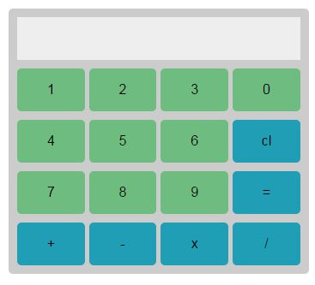

**Function:**

-Combo calculation

-Cross platform (IOS and Android)

**Code scaffold:**

**JQuery.js- JavaScript of JQuery Mobile.**

**Reset.css- set user interface for the background.**

**Main.css- set user interface of the calculator.**

**Calculator.js – coded with the function of all the calculation.**

**Index.html – the index page of the app.**

**Config.xml – the required file for Phonegap to convert the web document to a hybrid app package.**